Login Page: 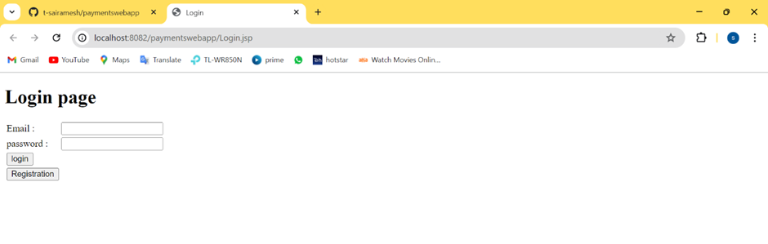

Invalid Case than go to Registration form: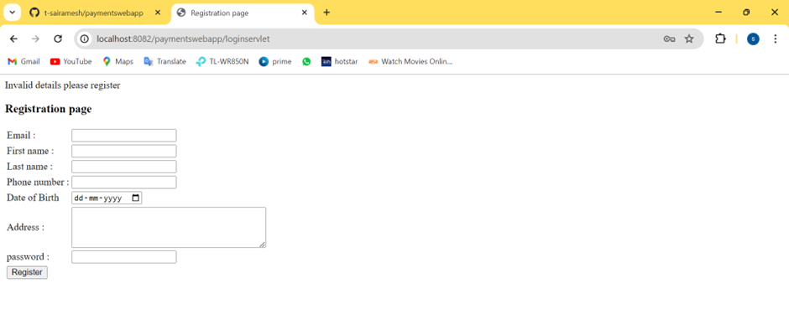

Valid Case

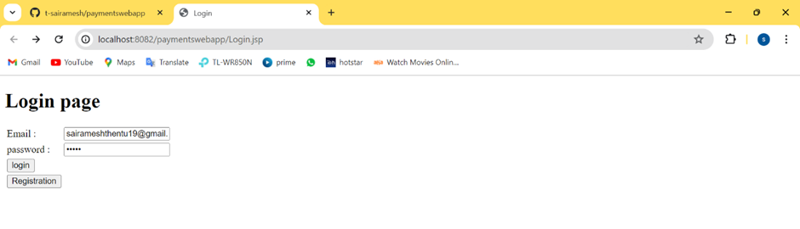

Dashboard page: